Nick Xinyuan Li April 15, 2024

Videogame Design and Critique | CMAC 755S Mechanics Check

The first mechanic is “Buy Food”.

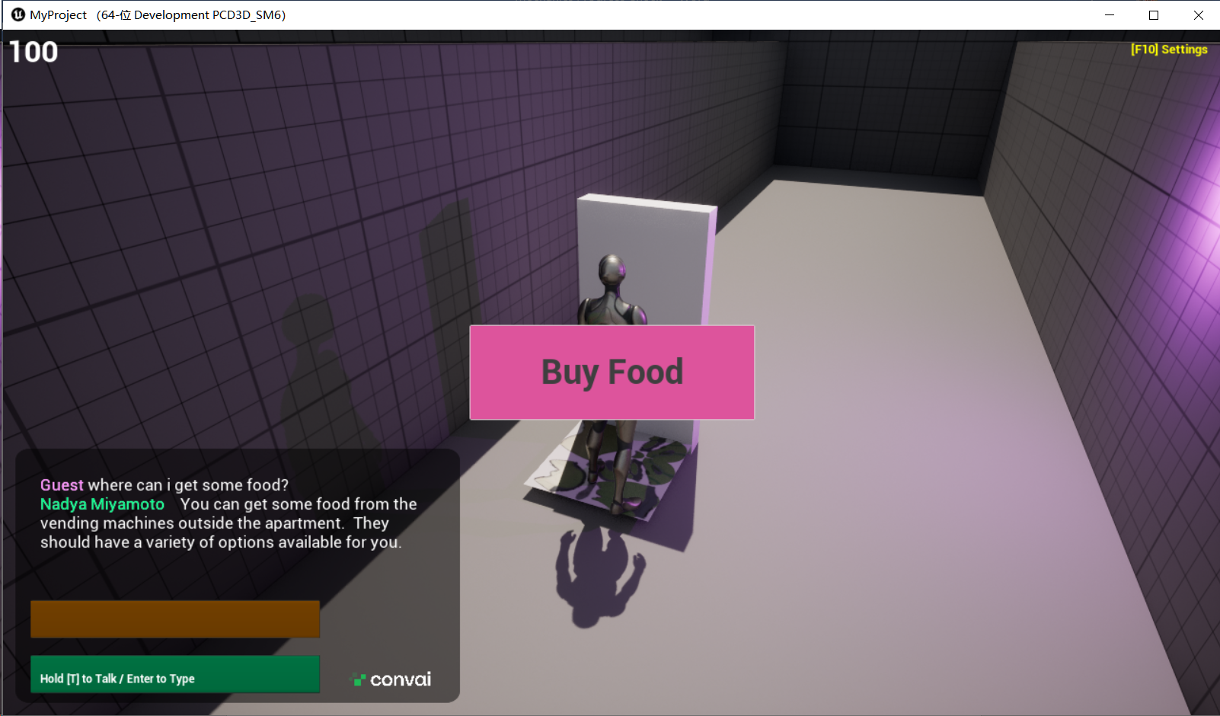

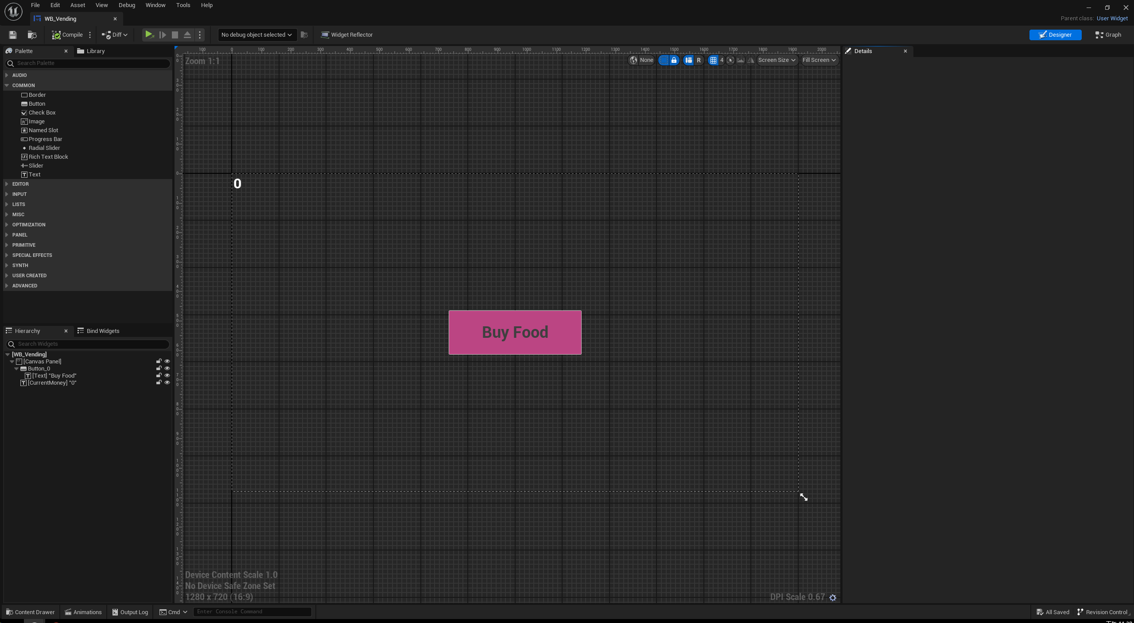

For the current money at top-left of the UI:

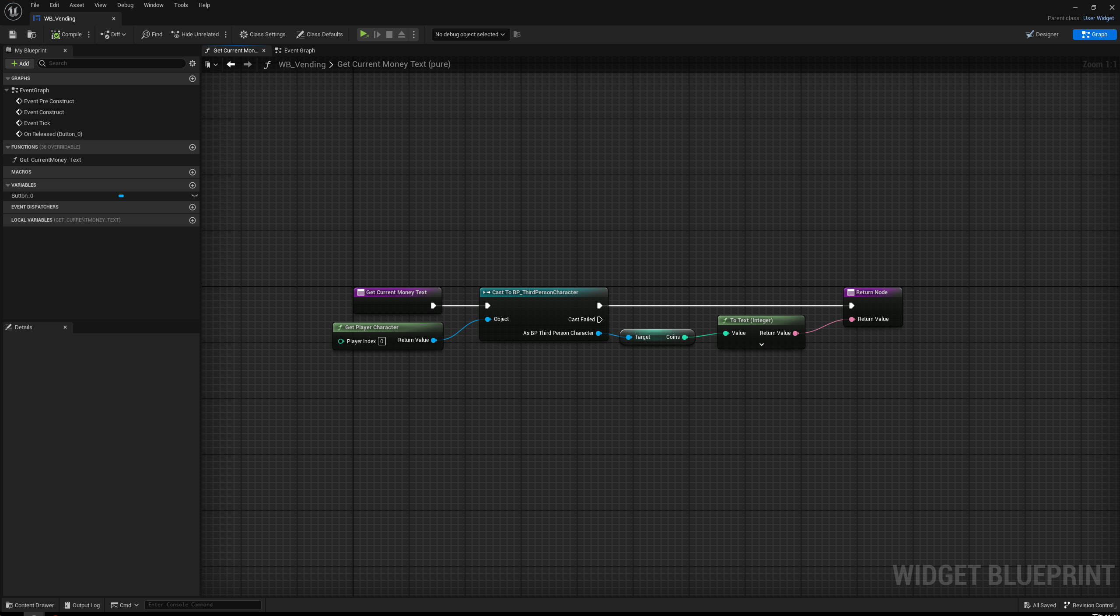

For the buy-food button.

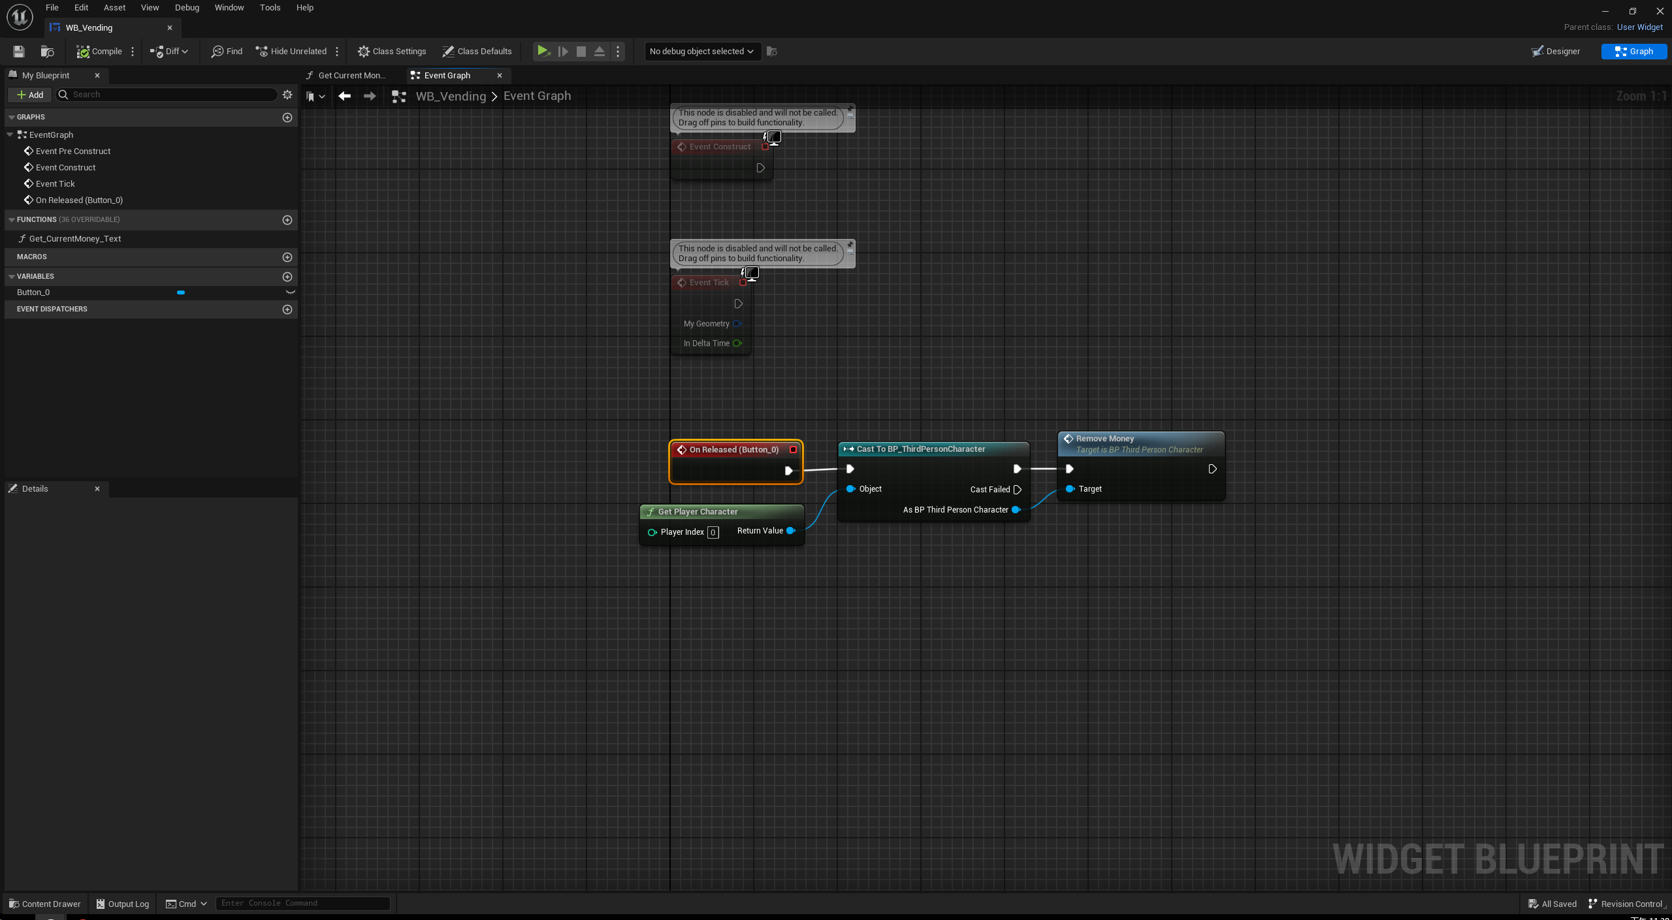

In BP_Vending:

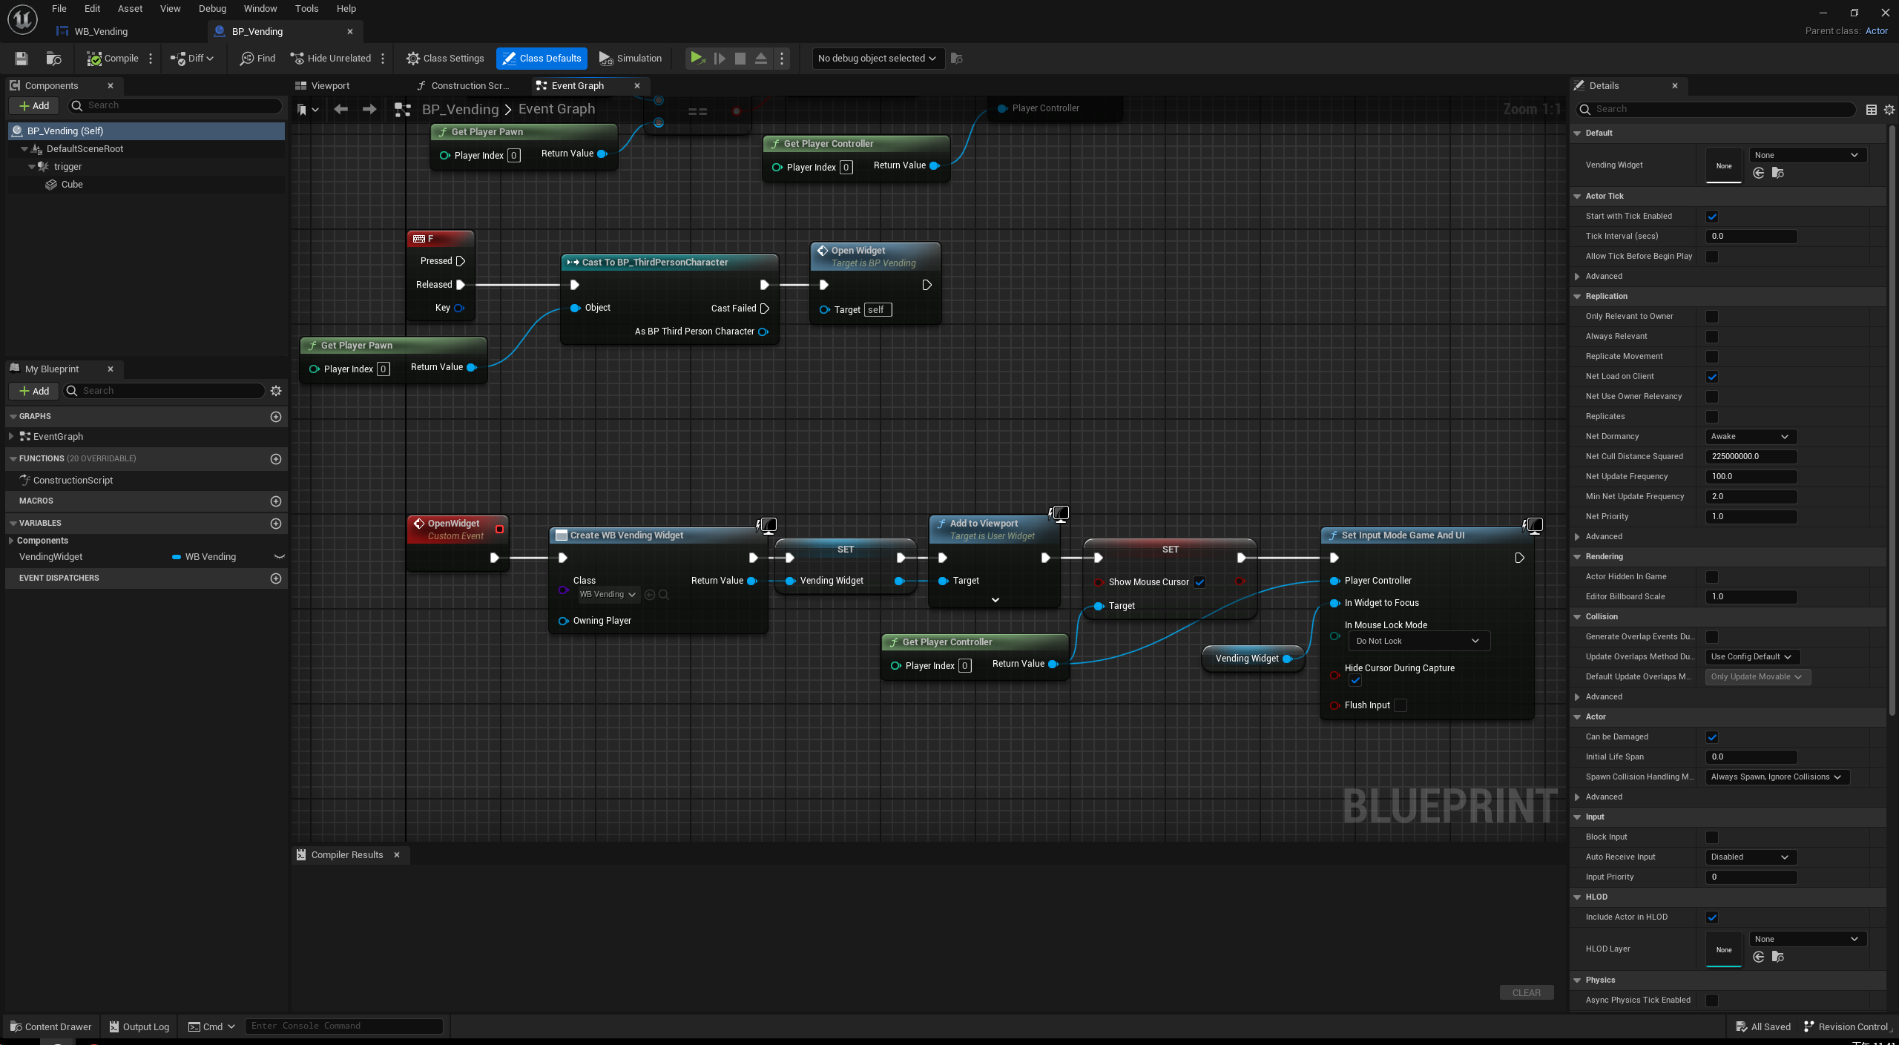

The second mechanic is NPC:

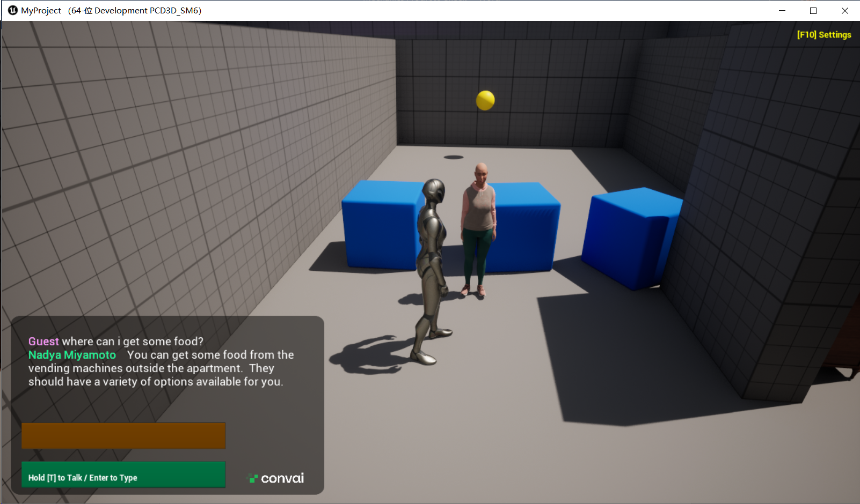

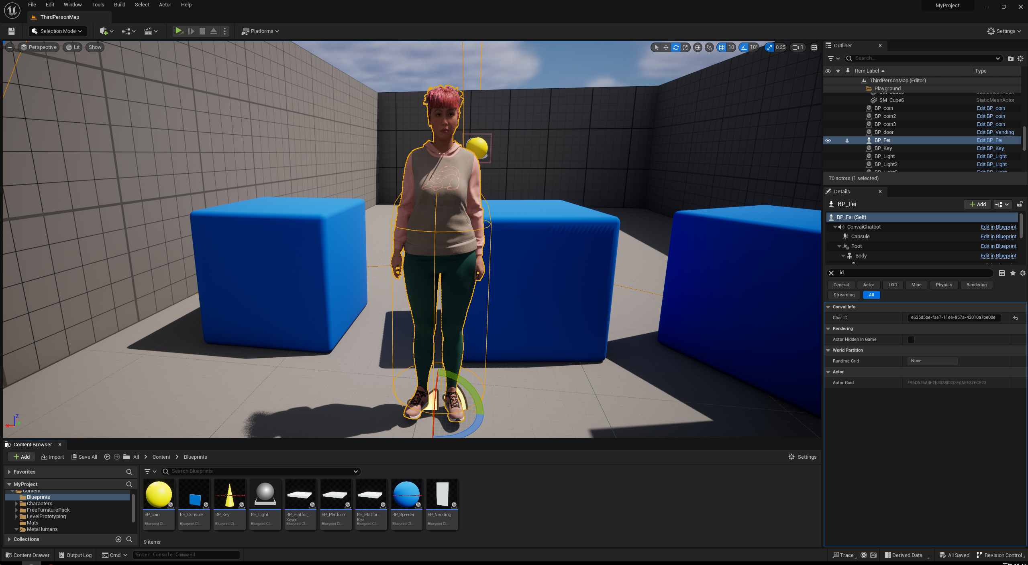

Most works are done on convai.com, also a plugin in ue5.

